**Output:**

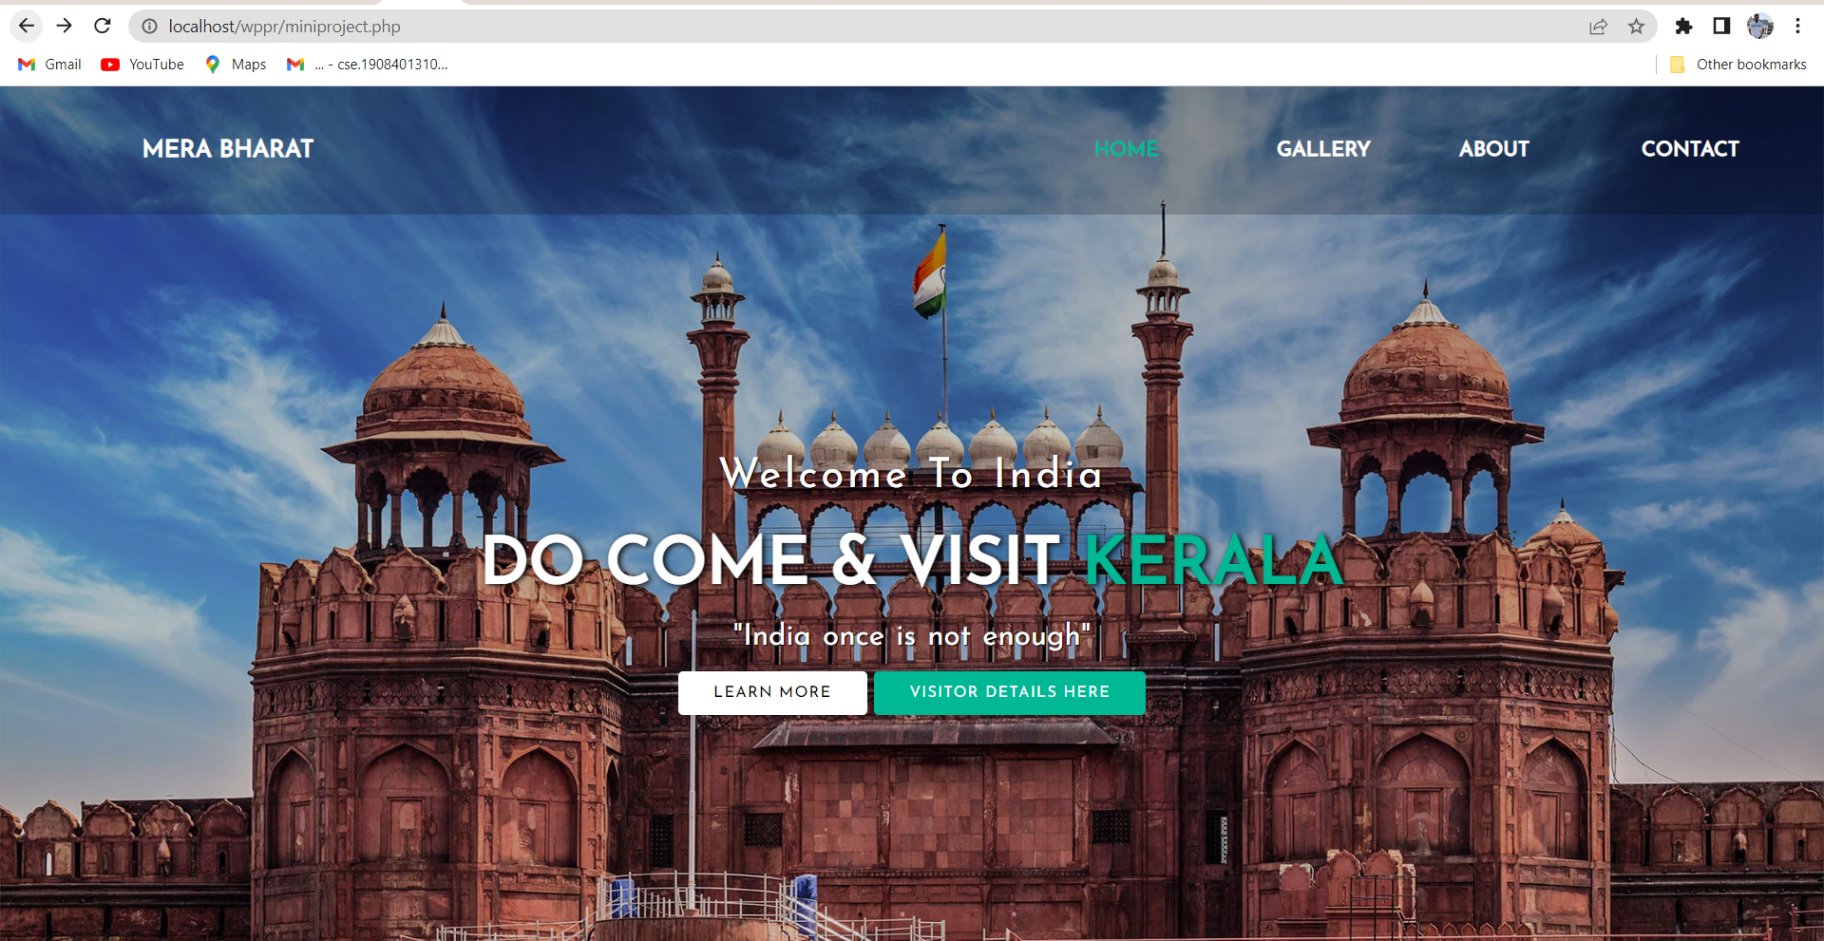

**Click on Gallery button it is asking about details:**

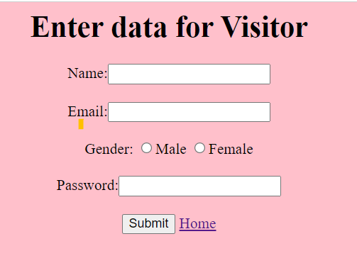



**After filling your details it is showing Gallery part :**

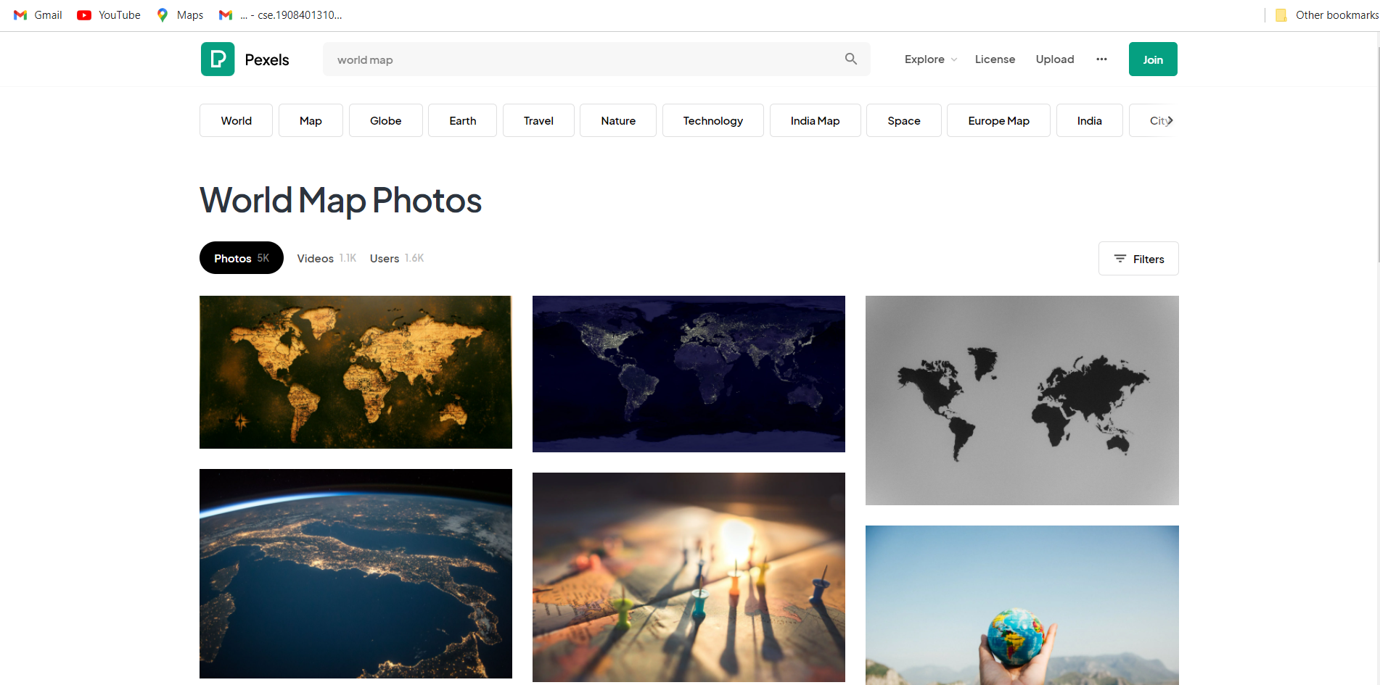

**Click on about button and fill your details:**

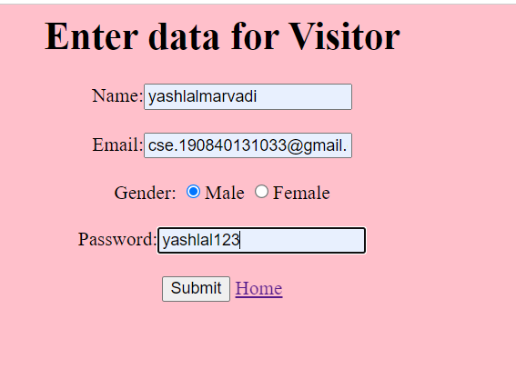



**Click on Contact button it is asking about details:**



**After filling your details it is showing contact part :**

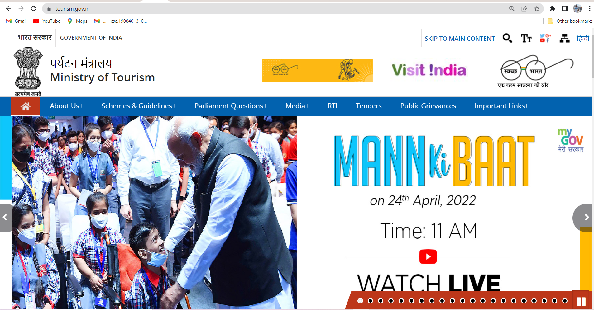

**Click on Learn more button:**

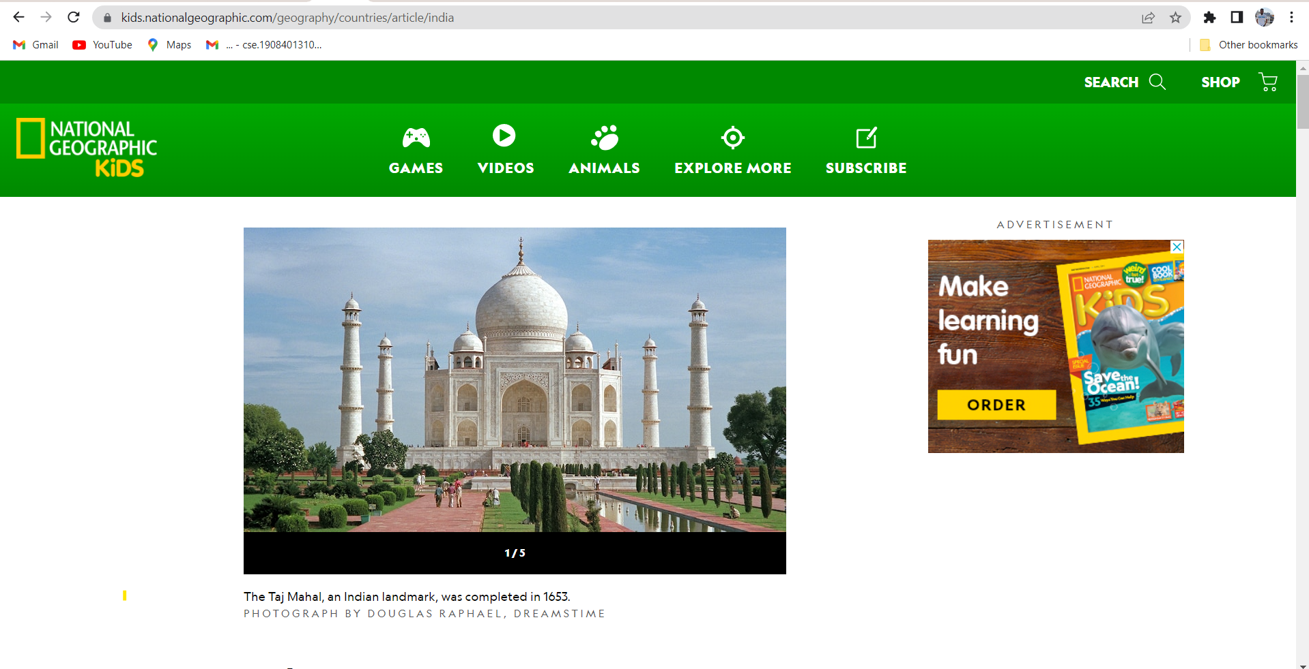

**Click on Visitor Details hear button it is showing all information about user who are visit my web site:**

